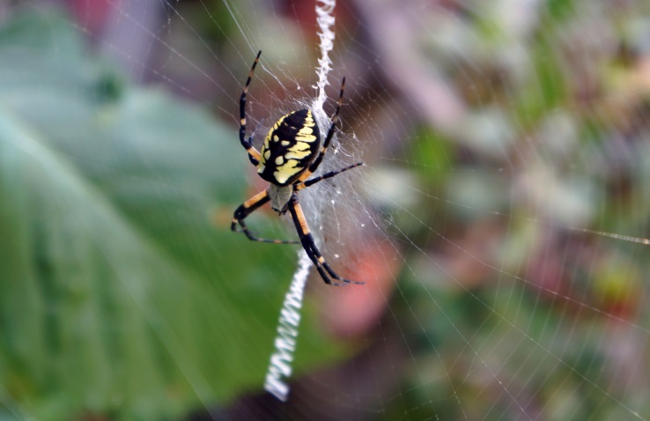
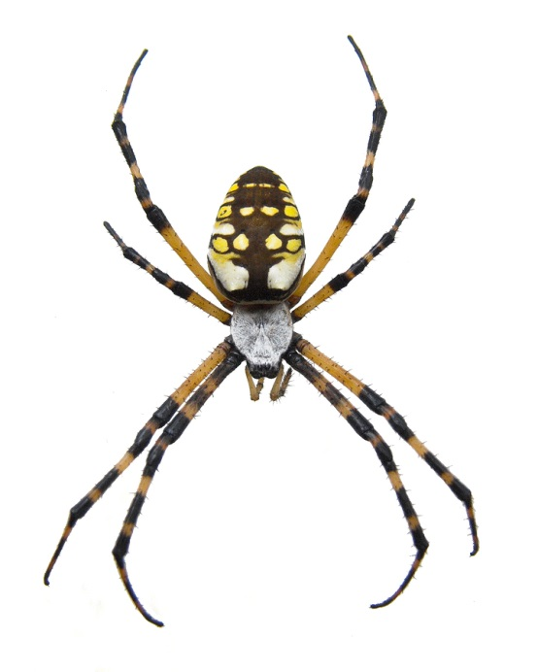
Yellow garden spiders are common in yards, fields and gardens. They prefer sunny spots with little or no wind. They are also called Black and Yellow Garden Spiders, Black and Yellow Argiopes, Corn Spider, Writing Spider or McKinley Spider.*
Females tend to remain in one spot, often staying in one place throughout much of their life. The female’s web is a distinctive circular shape up to 2 feet in diameter, with a dense zigzag of silk, in the center. The relatively nondescript male is much smaller than the female, and typically builds a smaller web nearby. The yellow garden spider often keeps her web in the same location for the entire summer, but she may change to a more suitable location with better hunting or exposure, especially early in the season.
Female
After mating, the female spider lays eggs up to 1,000 eggs on her web, then covers them with a papery sac. After laying her eggs, the female dies. The baby spiders hatch from their eggs in the fall, but remain inside the sac until spring when they leave the sac and go off on their own.
Argiopes are preyed on by birds, some wasps (especially mud daubers), lizards and other spider-eaters.
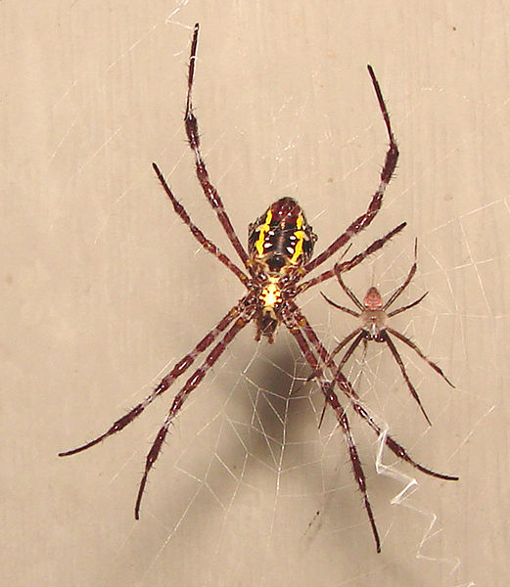
The yellow garden spider is not aggressive to people or other large animals. They may bite if grabbed and the bite is said to be comparable to a bee sting with redness and swelling. The bite is not typically an issue for healthy adults, but might be a problem to those with compromised immune systems or the elderly or to those allergic to the venom.*
The spiders feed on insects, small lizards (such as anoles and geckoes), et. al.
Source: * https://en.wikipedia.org/wiki/Argiope_aurantia)
Larger female with smaller male

